International comparison of age-specific presenting symptoms for patients admitted to hospital with coronavirus disease 2019
  - A draft analysis plan using data collected by the ISARIC Collaborators

Background
Large cohorts of patients with coronavirus disease 2019 (COVID-19) have been described in China,¹⁻⁴ Europe^{5,6} and United States.⁷ The most commonly reported symptoms have been grouped into clinical case definitions.⁸⁻¹¹ These can be used to classify suspected, probable and confirmed cases.¹²
Case definitions for COVID-19 generally require an epidemiological link demonstrating possible exposure to a case. However, as the global pandemic has spread, many countries have sustained community transmission meaning everyone is potentially exposed. For settings where microbiological testing for the causative pathogen (SARS-CoV-2) is not available, and for patients who have mild symptoms and do not seek medical attention, symptomology is the main feature for identifying possible cases. The World Health Organization’s surveillance case definition (used by the European and African Centres for Disease Control) for people who have been in a location with community transmission of COVID-19 requires fever and at least one sign or symptom of respiratory disease, such as cough or shortness of breath.⁸ The Centers for Disease Control and Prevention in the United States provides a list of symptoms: fever or chills, cough, shortness of breath or difficulty breathing, fatigue, muscle or body aches, headache, new loss of taste or smell, sore throat, congestion or runny nose, nausea or vomiting, and diarrhoea.⁹ The Public Health England definition of a possible case in the community is any one of new continuous cough, high temperature, or change to sense of taste or smell.¹⁰ For inpatients, the definition is evidence of pneumonia, acute respiratory distress syndrome, or one of two clusters of symptoms: fever with at least one of cough, hoarseness, nasal discharge or congestion, shortness of breath, sore throat, wheezing or sneezing; or any change in sense of taste of smell.¹⁰
The ISARIC COVID-19 report¹³ has already identified variation in symptoms by age (Figure). The age distribution of participants varies between countries.

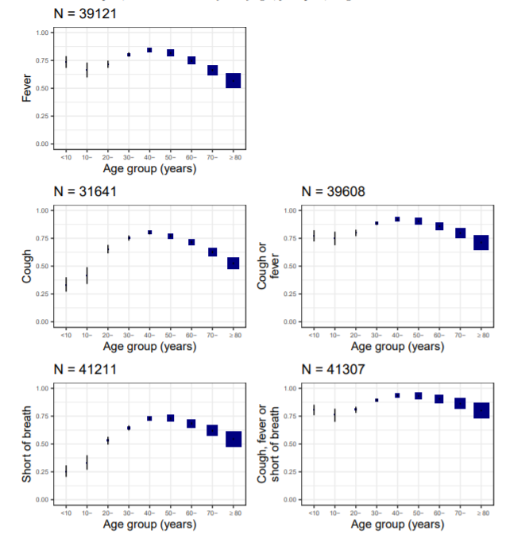
Figure Symptoms recorded at hospital presentation stratified by age group.
Reproduced from the ISARIC COVID-19 report, 8 June 2020 (https://media.tghn.org/medialibrary/2020/06/ISARIC_Data_Platform_COVID-19_Report_8JUN20.pdf)

Objectives
- To investigate patterns of symptoms at arrival to hospital for patients admitted to hospital with COVID-19, stratified by age, sex and country.
- To investigate the utility of commonly used clinical case definitions of COVID-19 for patients of different ages and in different countries.

Methods

Participants
Current understanding of COVID-19 symptoms risks biasing the results of this analysis, as those with atypical symptoms may be less likely to present to healthcare, be less likely to be tested for SARS-CoV-2, and be less likely to be included in the dataset. To reduce this as far as possible, only participants with laboratory-confirmed COVID-19 will be included in the main analysis. A sensitivity analysis will investigate the extent to which symptoms of participants with suspected COVID-19 differ. We will also exclude participants without details of age. No outcome data are included in this analysis, so it will not be necessary to exclude participants who were only recently admitted to hospital.

Data to include
All symptoms collected on the ISARIC case report forms will be included. We will generate a variable for participants with all symptoms recorded as absent at admission. For participants with non-missing data on fever, cough and shortness of breath, we will generate four variables corresponding to the clinical case definitions / symptom lists of the World Health Organization, Centers for Disease Prevention and Control, and Public Health England.⁸⁻¹⁰ For each symptom, we will record the proportion of missing and unknown data. No attempt will be made to impute missing data.

Plots
We will plot prevalence of symptoms according to age in ten-year bands, and according to country.

Statistical tests
We will use multivariable logistic regression to investigate the relationship between age, sex and country with symptoms. Age will be included as a continuous variable using fractional polynomials to account for its non-linear association. Countries will be included independently, and grouped by continent and World Bank income classifications.¹⁴ Likelihood ratio tests will be used to investigate the extent to which each is associated with symptoms.

Outputs
This analysis is intended to produce:
- Data for a peer-reviewed manuscript to be submitted jointly by the ISARIC investigators, in line with the ISARIC publication policy.
- R code that participating sites can use to analyse their own data.

Participatory approach
All contributors to the ISARIC database are invited to participate in this analysis through review and input on the statistical analysis plan and resulting publication. The outputs of this work will be disseminated as widely as possible to inform patient care and public health policy, this will include submission for publication in an international, peer-reviewed journal. ISARIC aims to include the names of all those who contribute data in the cited authorship of this publication, subject to the submission of contact details and confirmation of acceptance of the final manuscript within the required timelines.

References
1. Huang C, Wang Y, Li X, et al. Clinical features of patients infected with 2019 novel coronavirus in Wuhan, China. Lancet 2020; 395(10223): 497-506. doi: 10.1016/s0140-6736(20)30183-5
2. Chen N, Zhou M, Dong X, et al. Epidemiological and clinical characteristics of 99 cases of 2019 novel coronavirus pneumonia in Wuhan, China: a descriptive study. Lancet 2020; 395(10223): 507-13. doi: 10.1016/s0140-6736(20)30211-7
3. Wang D, Hu B, Hu C, et al. Clinical Characteristics of 138 Hospitalized Patients With 2019 Novel Coronavirus-Infected Pneumonia in Wuhan, China. JAMA 2020; 323(11): 1061-9. doi: 10.1001/jama.2020.1585
4. Guan WJ, Ni ZY, Hu Y, et al. Clinical Characteristics of Coronavirus Disease 2019 in China. N Engl J Med 2020; 382(18): 1708-20. doi: 10.1056/NEJMoa2002032
5. Docherty AB, Harrison EM, Green CA, et al. Features of 20 133 UK patients in hospital with covid-19 using the ISARIC WHO Clinical Characterisation Protocol: prospective observational cohort study. BMJ 2020; 369: m1985. doi: 10.1136/bmj.m1985
6. Lechien JR, Chiesa-Estomba CM, De Siati DR, et al. Olfactory and gustatory dysfunctions as a clinical presentation of mild-to-moderate forms of the coronavirus disease (COVID-19): a multicenter European study. Eur Arch Otorhinolaryngol 2020; 277(8): 2251-61. doi: 10.1007/s00405-020-05965-1
7. Coronavirus Disease 2019 in Children - United States, February 12-April 2, 2020. MMWR Morb Mortal Wkly Rep 2020; 69(14): 422-6. doi: 10.15585/mmwr.mm6914e4
8. World Health Organization. Global surveillance for COVID-19 caused by human infection with COVID-19 virus: Interim guidance. Geneva, Switzerland: World Health Organization, 2020.
9. Centers for Disease Control and Prevention. Symptoms of coronavirus. 2020. https://www.cdc.gov/coronavirus/2019-ncov/symptoms-testing/symptoms.html.
10. Public Health England. COVID-19: investigation and initial clinical management of possible cases. 2020. https://www.gov.uk/government/publications/wuhan-novel-coronavirus-initial-investigation-of-possible-cases/investigation-and-initial-clinical-management-of-possible-cases-of-wuhan-novel-coronavirus-wn-cov-infection.
11. Tsang TK, Wu P, Lin Y, Lau EHY, Leung GM, Cowling BJ. Effect of changing case definitions for COVID-19 on the epidemic curve and transmission parameters in mainland China: a modelling study. The Lancet Public health 2020; 5(5): e289-e96. doi: 10.1016/s2468-2667(20)30089-x
12. Hawker J, Begg N, Reintjes R, Ekdahl K, Edeghere O, van Steenbergen J. Communicable disease control and health protection handbook. 4th ed. Oxford, UK: John Wiley; 2019.
13. International Severe Acute Respiratory and Emerging Infections Consortium. COVID-19 Report: 08 June 2020, 2020.
14. World Bank. World Bank country and lending groups. 2020. https://datahelpdesk.worldbank.org/knowledgebase/articles/906519-world-bank-country-and-lending-groups.

